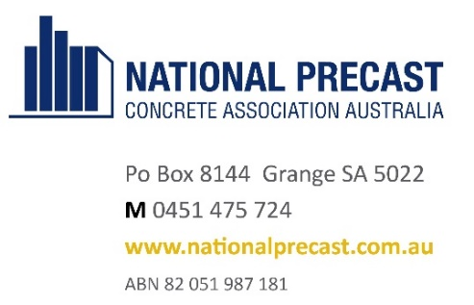

11th September, 2023

Dear precast colleague,

**Immerse yourself in 2 days of precast**

Whether you are a newcomer to National Precast or have previously been a member, a very warm welcome is extended to you to join us at our National Conference, being held at the Crown Plaza in the beautiful Sydney beachside location of Coogee from Monday, 30th October to Wednesday, 1st November 2023.

This conference will be bigger and better, and we thank our Conference Partner Leviat for their support.

We’ve introduced a Hawaiian themed Welcome Reception and Exhibition, where you can meet precasters and suppliers from all around Australia. We have a fantastic line-up of invited speakers at the full day Conference, which will be followed by an underwater themed Networking Dinner, with entertainment and prizes! And finally, for members only there’ll be a visit to the Metro West tunnel segment factory.

This Conference will bring together leaders in the precast industry from around the country, including precast manufacturers, suppliers and allied professionals. It will provide a wonderful opportunity to catch up with friends old and new… to see what our exhibitors have to offer, share information and learn.

You can register at [www.nationalprecast.com.au/events](http://www.nationalprecast.com.au/events), and if you need any registration assistance, please contact Shiva on 0451 475 724. Tickets are limited, so make sure you get in FAST!

We would love to see you there.

Kind regards,

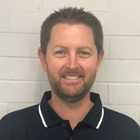 

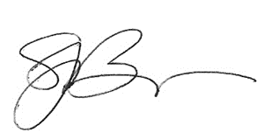

Jeff Stratford, President Sarah Bachmann, CEO

